Sprint 1 - Endurance Design Document

November 12th, 2020

Table of Contents

1. Executive Summary 3

1.1 Project Overview 3

1.2 Purpose and Scope of this Specification 3

2. Product/Service Description 3

2.1 Product Context 3

2.2 User Characteristics 3

2.3 Assumptions 3

2.4 Constraints 3

2.5 Dependencies 4

3. Requirements 4

3.1 Functional Requirements 5

3.2 Security 5

3.2.1 Protection 5

3.2.2 Authorization and Authentication 6

3.3 Portability 6

4. Requirements Confirmation/Stakeholder sign-off 6

5. System Design 6

5.1 Algorithm 6

5.2 System Flow 6

5.3 Software 6

5.4 Hardware 6

5.5 Test Plan 7

5.6 Task List/Gantt Chart 7

5.7 Staffing Plan 7

# Executive Summary

## Project Overview

This project will demonstrate to Professor Eckert, the sphero robot circumnavigating the path in room HH 208.

## Purpose and Scope of this Specification

Sphero robot with circumnavigate the perimeter of the room to show to Professor Eckert.

In scope

This document addresses requirements related to Endurance Sprint of Robot Project :

* Robot must start at blue arrow on yellow tile.
* Robot must have the color of green.
* Robot must say “Ready set go”.
* Robot must travel around perimeter of blue rectangle.

Out of Scope

The following items in Endurance Phase of Robot Project are out of scope:

* Robot must end back where it started.
* Robot must have color red when finished.
* Robot must say “I’m done and I need water”.

# Product/Service Description

Robot must circumnavigate HH 208 by following blue tape with arrows on ground. This robot must roll on ground and avoid hitting obstacles such as desks, chairs, and/or walls. In this section, describe the general factors that affect the product and its requirements. This section should contain background information, not state specific requirements (provide the reasons why certain specific requirements are later specified).

## Product Context

This robot is one of many different types produced by the company Sphero. The robot is independent of other robots and is self-contained within its ball form. It can be connected and utilized by anything that has a bluetooth connection and has the Sphero.edu app. The device connected to the robot can use remote controls or code to control what the robot does and how it moves.

## User Characteristics

General customer profiles:

* Can be used by almost anyone, i.e.: teachers, students, adults, kids, average joe.
* Little experience is needed to learn and understand how to control robot.
* User must have basic understanding of using a computer and minimal background in coding.
* Not for toddlers, will break if thrown or handled too roughly.

## Assumptions

Robot is properly charged, usage of floor space or designated area, and device with Bluetooth compatibility and the Sphero.edu application.

## Constraints

Constraints of design options:

* Updated version of bluetooth
* Updated version of Sphero.edu app
* Workspace due to social distancing and other safety precautions
* Personal devices, such as laptops or phones
* Required use of predesigned block codes on Sphero.edu app

## Dependencies

Dependencies that affect the requirements:

* Require occasionally updates to system software
* Must be the specific Sphero robot provided by university
* Block code must be completed first

# Requirements

* Robot must follow path of rectangle laid out in HH 208
* Priority 1:
  + Must start at blue arrow on yellow tile
  + Must have green light
  + Must say, “Ready set go”
  + Must travel to end of blue tape and turn right (roll at 0 degrees at 110 speed for 5.6 seconds)
  + Must continue until end of blue tape on that side and turn right (roll at 90 degrees at 110 speed for 3.3 seconds)
  + Must continue on that side of blue tape until it ends and turn right (roll at 180 degrees at 110 speed for 6 seconds)
  + Must continue on that path of bule tape until it is has reached where it started (roll at 270 degrees for at 110 speed for 3.55 seconds)
  + When done must turn red
  + Must say, “I’m done and I need water

## Functional Requirements

| Req# | Requirement | Comments | Priority | Date Rvwd | SME Reviewed / Approved |
| --- | --- | --- | --- | --- | --- |
| ENDUR_01 | Start program on blue arrow that is on the yellow tile | Required by Professor Eckert | 1 | 10/29/20 | 11/12/20 |
| ENDUR_02 | Set light to green | Required by Professor Eckert | 1 | 10/29/20 | 11/12/20 |
| ENDUR_03 | Speak “Ready set go” | Required by Professor Eckert | 1 | 10/29/20 | 11/12/20 |
| ENDUR_04 | Move Straight | Required by Professor Eckert | 1 | 10/29/20 | 11/12/20 |
| ENDUR_05 | Move Right | Required by Professor Eckert | 1 | 10/29/20 | 11/12/20 |
| ENDUR_06 | Move Straight | Required by Professor Eckert | 1 | 10/29/20 | 11/12/20 |
| ENDUR_07 | Move Right | Required by Professor Eckert | 1 | 10/29/20 | 11/12/20 |
| ENDUR_08 | Stop and set light to red | Required by Professor Eckert | 1 | 10/29/20 | 11/12/20 |
| ENDUR_09 | Speak “I’m done and need water” | Required by Professor Eckert | 1 | 10/29/20 | 11/12/20 |

## Security

### Protection

Factors that will protect the system:

* Keep account information for github.com and Sphero.edu secret
* Logging activity
* Historical data sets
* Charting roles and who does specific jobs

### Authorization and Authentication

Use of Github.com and Sphero.edu and Microsoft Office products through our accounts

## Portability

Specify attributes of the system that relate to the ease of porting:

* Host dependent code is used for entire block code in controlling robot
* Used JavaScript in block code form on Sphero.edu
* Works with specific block code set up on any compatible device
* Works anywhere there is enough space

# Requirements Confirmation/Stakeholder sign-off

Include documentation of the approval or confirmation of the requirements here. For example:

|  |  |  |
| --- | --- | --- |
| Meeting Date | Attendees (Names and Roles) | Comments |
| 11/11/20 | Michael (Co-manager)  Daniel (Co-manager) | Met together to finalize block code and confirm all requirements have been met. |

# System Design

This section will provide all details concerning the technical design, staffing, coding, and testing the system

## Algorithm

* Start program on blue arrow that is on the yellow tile
* Set light to green
* Speak “Ready set go”
* Move Straight
* Move Right
* Move Straight
* Move Right
* Stop and set light to red
* Speak “I’m done and need water”

## System Flow

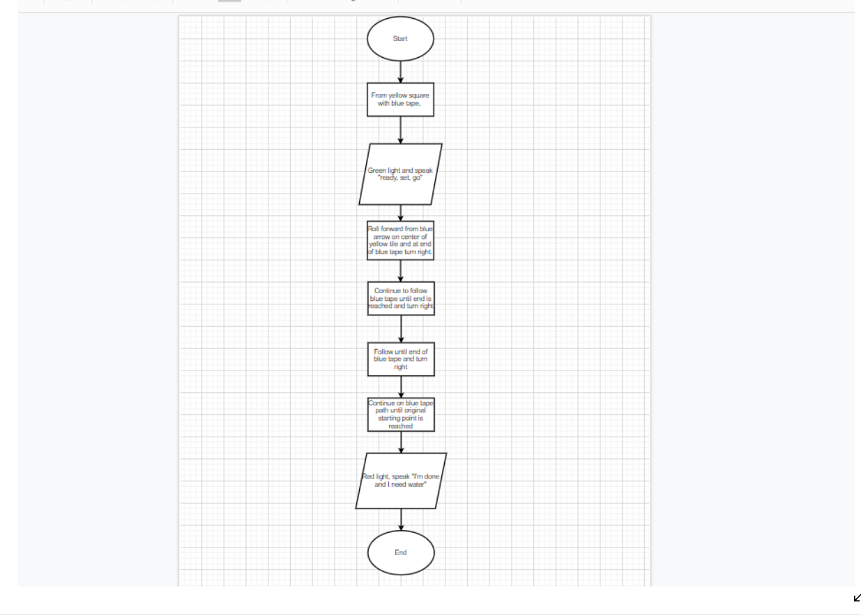

## 

## Software

Block code that is a representation of JavaScript which was controlled through the Sphero Edu software.

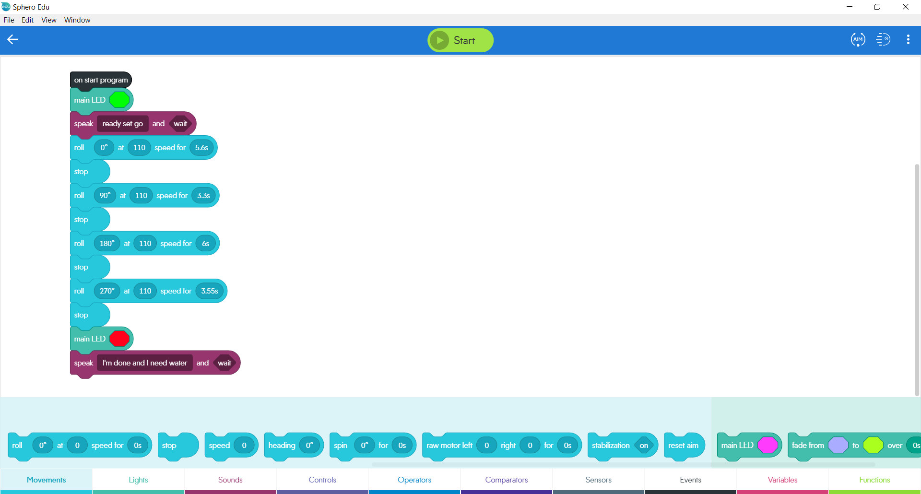

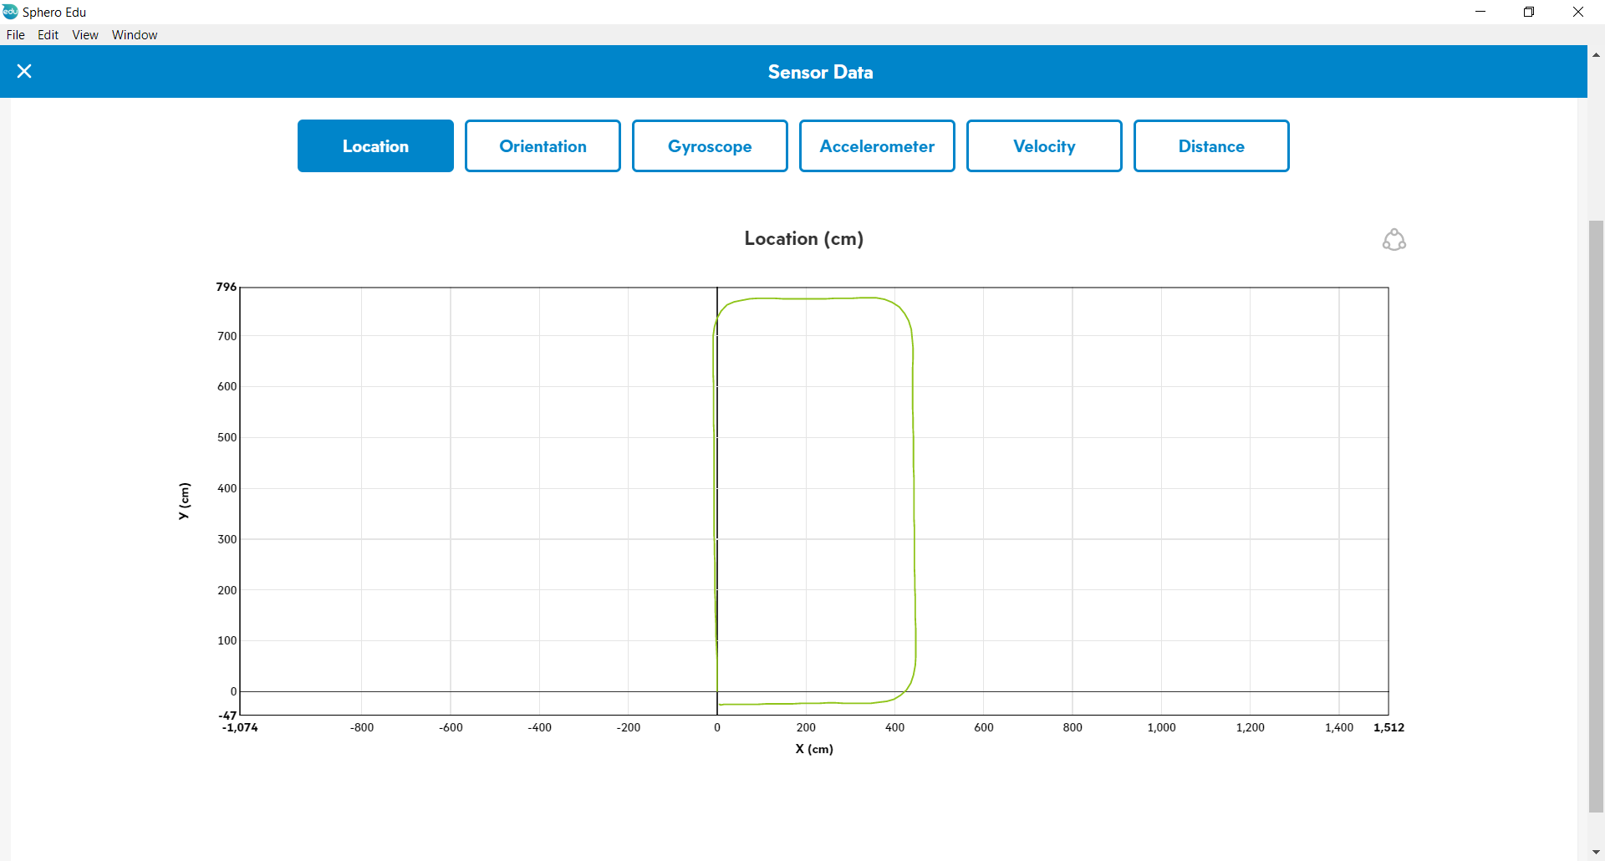

## Hardware

Sphero Edu was used to control the Sphero robot which was version SPRK+. This was done through Bluetooth from a personal laptop that allowed connection between the SPRK+ and the Sphero Edu app to access the block code.

## Test Plan

|  |  |  |  |  |  |
| --- | --- | --- | --- | --- | --- |
| **Reason for Test Case** | **Test Date** | **Expected Output** | **Observed Output** | **Staff Name** | **Pass/Fail** |
| First Test | 11/11/20 | Errors and unknown | Went to far outside of the path and was not timed correctly | Michael/Daniel | Fail |
| Fix calibration | 11/12/20 | Fixed time and correct course adjustment | Started off good but made the first turn too wide and messed up the rest of the course | Michael/Daniel | Fail |
| Fix calibration | 11/12/20 | Fixed time should allow for good course run | The second turn was too wide and caused the SPRK+ to bump into a chair | Michael/Daniel | Fail |
| Fix calibration | 11/12/20 | Fixed speed and time should allow for smooth run | Started the initial path off centered most likely due to bad adjustment | Michael/Daniel | Fail |
| Fix calibration | 11/12/20 | Fixed the SPRK+ initial starting position | Ran the course smoothly but just stopped short of the initial starting line | Michael/Daniel | Fail |
| Fix calibration | 11/12/20 | Fixed the time for the stopping point of the SPRK+’s at the end | Ran the course within an acceptable error of margin | Michael/Daniel | Pass |

## Task List/Gantt Chart

Full Gnatt chart on GitHub [here](https://github.com/mikeschmid25/Endurance.git)



## Staffing Plan

|  |  |  |  |
| --- | --- | --- | --- |
| Name | Role | Responsibility | Reports To |
| Michael | Co-manager | Oversee and complete all parts of assignment | Professor Eckert |
| Daniel | CO-manager | Oversee and complete all parts of assignment | Professor Eckert |